October 22, 2024



Land Use Permit Application for Soil & Water Conservation District Sign Installation

LUP-SWCD
The placement of Soil & Water Conservation District identiﬁcation signs on state-maintained highway right-of-way is permitted pursuant to Section 24VAC30-151-660 of the Land Use Permit Regulations.

I the undersigned hereby acknowledge that I am fully cognizant of and, in my individual capacity and as a duly authorized representative of the entity applying for this permit, agree to all of the following requirements associated with the issuance of a VDOT Land Use Permit authorizing the installation of Soil & Water District Signs on state-maintained highways.

Type or Print Clearly

Name of Applicant: Applicant’s Tax ID No.: Applicant’s Mailing Address: City : State: Zip Code: Primary Telephone No.: 24-Hour Telephone No.: Email Address: Work Description:

Locality: Route Name and Number: Route to: Route from: Coordinates: Latitude Longitude Name of Applicant’s Duly Authorized Representative:

Representative’s Title: Representative's Signature:

VDOT Land Use Permit Required by Law
The General Rules and Regulations of the Commonwealth Transportation Board provide that no work, occupancy, or non-transportation uses of any nature may be allowed or performed on the system of state highways or any real property under the ownership, control, or jurisdiction of VDOT until written permission has been obtained from VDOT. Written permission is granted for the above-referenced activity through the issuance of a land use permit.
By issuing a permit, VDOT is giving permission only for whatever rights it has in the right-of-way; the Permittee is solely responsible for determining all entities that may have a property interest of any kind or nature in the right-of-way and for obtaining permission from all such entities for the Permittee’s use of the right-of-way and shall be solely liable for any failure to obtain from any and all entities having a property interest in the right-of-way.
The Permittee will be civilly liable to the Commonwealth for all actual damage caused by a violation of the terms of the permit or 24VAC30-151-40.I.

Application Information
Application for a land use permit authorizing the placement of Soil & Water Conservation District identiﬁcation signs on non-limited access state-maintained highways shall be made through the local district permit office where the activity is to take place.
The permit applicant shall stake out the requested sign location for ﬁeld review by the district administrator’s designee.
The district administrator’s designee receiving the request shall coordinate review and approval of the request with all appropriate VDOT personnel

Contact Information
A list of counties with their corresponding VDOT district offices and contact information may be obtained on the VDOT web site at: https://www.vdot.virginia.gov/about/districts/

Permit Fees & Surety Requirements
The land use permit fee and surety for the placement of Soil & Water Conservation District identiﬁcation signs within state-maintained highway right-of-way shall be waived.

Insurance Requirements (excluding County, Town, or City)

The permittee or their agent shall secure and maintain commercial general liability insurance to protect against liability for personal injury and property damage in connection with all activities undertaken under a permit. Comprehensive general liability insurance with limits of at least $1,000,000 per occurrence and $5,000,000 aggregate, or in amounts otherwise required by VDOT as stated in the permit, shall be maintained at all times. Insurance must be obtained prior to start of the permitted work and shall remain valid through the permit completion date. VDOT staff may require a valid certiﬁcate of insurance or policy documents from the issuing insurance agent or agency prior to issuing a permit

General Requirements
- Permittee acceptance and use of a Virginia Department of Transportation (VDOT) land use permit is prima facie evidence that the permittee has read and is fully cognizant of all required permit provisions, applicable traffic control plans, and associated construction standards to be employed. All applicants to whom permits are issued shall at all times indemnify and hold harmless the Commonwealth, the Commonwealth Transportation Board, the Commissioner of Highways, VDOT, and their consultants, representatives, agents and employees from and against any and all claims, causes of action, losses, costs, attorney's fees, expenses, and damages that directly or indirectly results from or arises out of the permittee's activities or violations in the right-of-way or from any of the permittee's contractors, subcontractors, consultants, representatives, agents or employees, or from anyone for whose acts or violations the permittee is or may be liable.
- The permittee assumes full responsibility for any damages that may occur as a result of the work performed under this permit. Furthermore, the Department will in no way be responsible for any damage to the facility being placed as a result of future maintenance or construction activities performed by the Department.
- The permittee agrees to move, remove, alter, or change any deployment that interferes with the construction of the highway at no cost to the Department unless otherwise stipulated and agreed to by the Department.
- The permittee shall immediately correct any situation that may arise from their activities that the district administrator’s designee deems hazardous to the traveling public.
- Any highway signs, right-of-way markers, etc., disturbed by work performed under the auspices of a land use permit shall be accurately reset by the permittee immediately following the work in the vicinity of the disturbed facility. The services of a certified land surveyor with experience in route surveying may be required.
- It shall be the permittee's responsibility to obtain all necessary permits that may be required by any other government agencies, i.e., U.S. Army Corps of Engineers, Department of Environmental Quality, Department of Conservation and Recreation.
- A copy of the VDOT land use permit shall be maintained at the work site and made readily available for inspection when requested by authorized VDOT personnel.
- The permittee shall notify the local district permit office at least 48 hours prior to commencement of any work requiring inspection and/or testing. Failure to carry out this requirement may result in permit revocation.
- It is the duty of the district administrator’s designee to keep all roads maintained in a safe and travelable condition at all times. Therefore, any permit may be denied, revoked, or suspended when in the opinion of the district administrator’s designee, the safety, use, or maintenance of the highway so requires.
- The permittee shall at all times give strict attention to the safety and rights of the traveling public, their employees, and themselves. VDOT reserves the right to stop work at any time due to safety problems and/or non-compliance with the terms of the permit. The Department may, at its discretion, complete any of the work covered in the permit or restore the right-of-way to the department’s standards and invoice the permittee for the actual cost of such work. The permittee may be required to move, alter, change, or remove from state-maintained right-of-way, in a satisfactory manner, any installation made under this permit.
- All work authorized under the auspices of a VDOT land use permit shall be subject to VDOT’s direction.
- Design changes, specified material changes, and/or field changes from the approved plans shall be submitted to the appropriate district administrator’s designee for review and approval prior to proceeding with the proposed changes. This submittal shall include written justification, supplemental documentation, and/or engineering calculations that support the requested changes.

Permit Speciﬁc Requirements
- The Soil &Water Conservation District is responsible for the fabrication, installation and maintenance of all signs authorized for placement on state-maintained highway right-of- way.
- The Soil & Water Conservation District will provide the sign fabricator an appropriate graphic ﬁle of the Virginia Soil & Water Conservation District pictograph for use on the sign.
- All Soil & Water Conservation District identiﬁcation signs shall be fabricated in accordance with the approved design speciﬁcations as shown herein.
- Signs shall be installed in accordance with VDOT Road and Bridge Standards 1321.10- 1321.51.
- The placement of Soil & Water Conservation District identiﬁcation signs on state maintained right-of way shall be restricted to highways designated as non-limited access primary and secondary routes.
- The district administrator’s designee may alter the requested location based on engineering judgment, and/or safety concerns to protect the traveling public.
- All Soil & Water Conservation District identiﬁcation signs should be located as close to the right-of-way line as reasonably possible.
- All Soil & Water Conservation District identiﬁcation signs must be located in such a manner that will not interfere with sight distance for driveways and intersections, be a distraction to motorists or pose a safety hazard to the traveling public.
- Soil & Water Conservation District identiﬁcation signs shall not be installed in the median area of any state-maintained highway, on a bridge, or within 500 feet of any bridge approach.

Traffic Control and Safety
- In accordance with the Virginia Department of Transportation (VDOT) Road and Bridge Specification, Special Provision 105.14, all activities performed under the auspices of a VDOT Land Use Permit involving the installation, maintenance and removal of work zone traffic control devices must have an individual on-site who, at a minimum, is accredited by VDOT in Basic Work Zone Traffic Control. The accredited person must have their VDOT Work Zone Traffic Control accreditation card in their possession while on-site.
- The individual accredited in Basic Work Zone Traffic Control is responsible for the placement, maintenance, and removal of work zone traffic control devices within the work zone in compliance with the permit requirements and conditions, and the approved plans.
- A person accredited by VDOT in Intermediate Work Zone Traffic Control must be on-site to provide supervision for adjustment to the approved layout.
- Individuals responsible for implementation of work zone traffic control measures shall provide evidence of their accreditation upon request from VDOT personnel.
- The permittee shall be exempt from the requirements of Virginia Department of Transportation (VDOT) Road and Bridge Specification, Special Provision 105.14 if the authorized activity is not within the roadway (as defined in 24VAC30-151) of a state-maintained highway.
- All activities that require the disruption (stoppage) of traffic on two-lane undivided roads shall utilize flaggers who have a valid and unexpired VDOT Flagger, ATSSA Flagger, VDOT Basic Work Zone, or VDOT Intermediate Work Zone card. VDOT will not accept VDOT Flagger Cards issued after December 31, 2024; VDOT Flagger Cards issued prior to December 31, 2024, will only be accepted until their date of expiration (two years after date of issuance). Flag persons shall be provided in sufficient number and locations as necessary for control and protection of vehicular and pedestrian traffic. All flaggers must have their certification card in their possession when performing flagging operations within state-maintained right-of-way. Any flag person found not in possession of his/her certification card shall be removed from the flagging site and the district administrator’s designee will suspend all permitted activities.
- Any certified flag person found to be performing their duties improperly shall have their certification revoked.
- Traffic shall not be blocked or detoured without permission, documented in writing or electronic communication, being granted by the district administrator’s designee.
- The permittee shall notify the following appropriate VDOT Transportation Operations Center (TOC) 30 minutes prior to the installation of a lane closure or shoulder closure on non-limited access primary routes and within 30 minutes of removing the lane or shoulder closure:
•Eastern Region (757) 424-9920: All localities within the Hampton Roads Construction District excluding Greenville County and Sussex County
•Northern Virginia (703) 877-3401: All localities within the NOVA Construction District plus Spotsylvania County and Stafford County
•Central Region (804) 796-4520: All localities within the Richmond Construction District, plus Greenville County and Sussex County. All localities within the Fredericksburg District, excluding Spotsylvania County and Stafford County
•SW Region (540) 375-0170: All localities within the Salem, Bristol, and Lynchburg Construction Districts
•NW Region (540) 332-9500: All localities within the Staunton and Culpeper Construction Districts
Information regarding how to obtain access and the requirements for entry of lane closure requests in LCAMS and VaTraffic will be provided by the local permit office.

Authorized Hours and Days of Work

Normal hours for work under the authority of a VDOT land use permit are from 9:00 a.m. to 3:30 p.m. Monday through Friday for all highways classiﬁed as arterial or collector. All highways classiﬁed as local roads will have unrestricted work hours and days.
The district administrator’s designee may establish alternate time restrictions in normal working hours for single use permits.
The central office permit manager may establish alternate time restrictions in normal working hours for district-wide permits.
The classiﬁcations for all state-maintained highways can be found at the following link:
https://www.vdot.virginia.gov/projects/roads-classified/

Holiday Restrictions

Non-emergency work will not be allowed on arterial and collector highway classiﬁcations from noon on the preceding weekday through all state observed holidays. If the observed holiday falls on a Monday, the non-emergency work will not be allowed from noon on the preceding Friday through noon on Tuesday.

Installation
Prior to installation, the permittee shall comply with the terms of Title 56, Chapter 10.3 of the Underground Utility Damage Prevention Act and §56-265.14 through §56-265.20 of the Code of Virginia. This permit does not grant permission to grade on or near property of others or adjust or disturb in any way existing utility poles or underground facilities within the permitted area. Permission to do so must be obtained from the impacted utility company and any expense involved shall be borne by the permittee. Any conflicts with existing utility facilities must be resolved between the permittee and the utility owner(s) involved.
The permittee or their agent must contact the VDOT Customer Service Center at 1-800-367-7623 a minimum of 48 hours prior to initiating any planned excavation within 1,000 feet of a signalized intersection and/or near VDOT ITS infrastructure. Excavation activities may proceed only after the VDOT regional utility location agent has notified the permittee that the utility marking has been completed. Additional information can be found at: IIM-TMPD-541, IIM-TE-383, IIM -OD-16-01, Request for Marking VDOT Utility Location (virginia.gov)
Alternately, within all localities in the Northern Virginia Construction District, including the Counties of Arlington, Fairfax, Loudoun & Prince William, the Cities of Alexandria, Fairfax, Falls Church, Manassas and Manassas Park, and the Towns of Clifton, Dumfries, Hamilton, Haymarket, Herndon, Hillsboro, Leesburg, Lovettsville, Middleburg, Occoquan, Purcellville, Quantico, Round Hill and Vienna, and on Interstate 95 in the counties of Stafford, Spotsylvania and Caroline, the permittee may request VDOT regional utility marking at: http://www.vdotutilitymarking.virginia.gov
Failure to carry out this requirement may result in permit revocation.

Environmental

- In accordance with the Virginia Department of Transportation (VDOT) Road and Bridge Speciﬁcation 107.16, all contractors performing regulated land disturbing activities within VDOT right-of-way must have at least one (1) employee that has successfully completed the VDOT Erosion & Sediment Control Contractor Certiﬁcation training. This person shall be on site during all land disturbance activities and will be responsible for insuring compliance with all applicable local, state, and federal erosion and sediment control regulations during land disturbance activities. This person must have their certiﬁcation card with them while on the project site. The land use permit will be suspended if proof of certiﬁcation cannot be provided. Regulated land disturbing activities are deﬁned as those activities that disturb 2,500 square feet or greater in Tidewater, Virginia or 10,000 square feet or greater in all other areas of the State. The Department will require evidence of this certiﬁcation with any land use permit application that involves utility and/or commercial right of way improvement. Improper installation, maintenance and removal of erosion and sediment control devices may result in revocation of VDOT Erosion & Sediment Control Contractor Certiﬁcation.
- The permittee is responsible for pursuing and obtaining any and all environmental permits which may be required to pursue the proposed activity prior to any work beginning within state-maintained right-of-way.
- In the event hazardous materials or underground storage tanks are encountered within state-maintained right-of-way during authorized activities, the permittee shall suspend all work immediately then notify the local district permit office and other responsible parties, i.e., the local ﬁre department, emergency services, Department of Environmental Quality, etc. The permittee is responsible for coordination and completion of all required remediation necessary to complete the permitted activities within the state-maintained right-of-way. The permittee shall provide evidence of such compliance to the local district permit office prior to recommencement of permitted activities.
- In the event cultural resources, archaeological, paleontological, and/or rare minerals are encountered within the right of way during authorized activities, the permittee shall suspend all work immediately then notify the local district permit office and the proper state authority charged with the responsibility for investigation and evaluation of such ﬁnds. The permittee will meet all necessary requirements for resolving any conﬂicts prior to continuing with the proposed activities within the state-maintained right-of-way and shall provide evidence of such compliance to the local district permit office.
- Roadway drainage shall not be blocked or diverted. The shoulders, ditches, roadside, drainage facilities and pavement shall be kept in an operable condition satisfactory to the Department. Necessary precautions shall be taken by the permittee to insure against siltation of adjacent properties, streams, etc.

Final Inspection and Completion of Permit
Upon completion of the work covered by this permit all disturbed areas outside of the roadway prism shall be restored to their original condition as found prior to starting such work.
Completion of this permit is contingent upon the permittee’s completion of the authorized work in accordance with the approved plan and compliance with all governing bodies involved in the total completion of work on state-maintained right-of-way.
Upon completion of the work under permit, the permittee shall provide notiﬁcation, documented in writing or electronic communication, to the district administrator's designee requesting ﬁnal inspection. This request shall include the permit number, county name, route number and name of the party or parties to whom the permit was issued.
The district administrator's designee shall promptly schedule an inspection of the work covered under the permit and advise the permittee of any necessary corrections.

Soil & Water Conservation District Sign Speciﬁcations
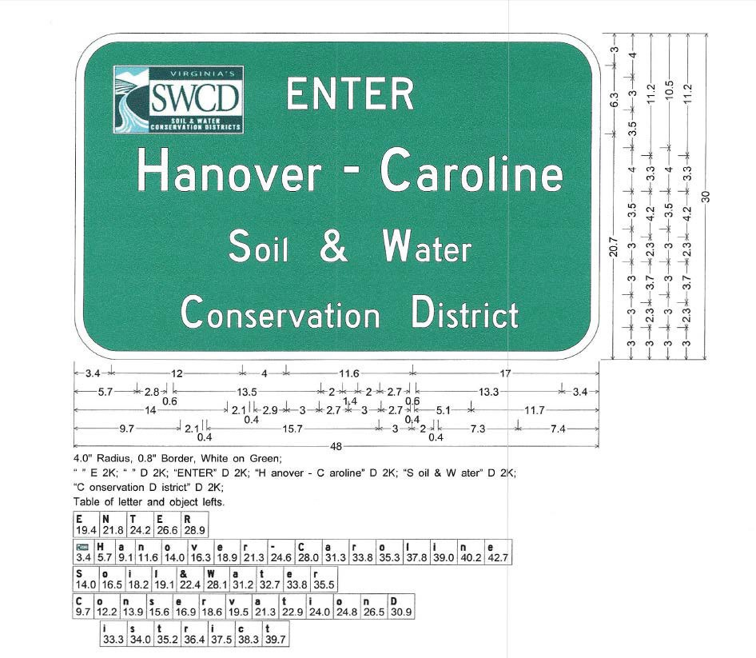
NOTES:
Sign panel sheathing material = 3M diamond grade, Type IX Sign panel background color = Green #3997 Sign panel border & lettering color = White #3990
Sign posts shall be approved by the district administrator’s designee prior to permit issuance.
Ground mounted sign panels installed along the roadside in rural areas shall mounted at a height of at least 7 feet, measured vertically from the bottom of the sign panel to the nearest edge of pavement and no closer than 6 feet, measured horizontally from the closest edge of the sign panel to the nearest edge of pavement.
Ground mounted sign panels installed along the roadside in urban areas shall mounted at a height of at least 7 feet, measured vertically from the bottom of the sign panel to the nearest edge of the traveled way and no closer than 2 feet, measured horizontally from the closest edge of the sign panel to the nearest edge of the traveled way.

